Team members:

Lab 1

Background

HTTP, a session layer (5) protocol, depends on TCP, a transport layer (4) protocol.

HTTP addresses are of the form,
http://host[:port] [/path [? query] [# fragment]]

The host portion is expressed as 32-bit Internet addresses “dotted quad.” If you use a symbolic name, the name must be resolved by the Domain Name Server or DNS host which converts the name to a 32-bit number.
As for the port, TCP port numbers range from 0 - 65535.

In our first lab, we’ll gain some familiarity with EasyPHP and the Brackets editor. While this project could be done without any php at all, it will help us get started by working with some HTML, which is hopefully familiar to everyone in the class.

Tasks

1. If you are completing this assignment using one of the Marist lab computers, then EasyPHP is already installed for your use. Skip to step 2 below. Otherwise, if you’re completing this assignment on another Windows computer, then download and install EasyPHP from http://www.easyphp.org/. Get the DevServer latest version that’s supported for your version of the Windows operating system (probably 17.0).

2. Open EasyPHP by double-clicking on the EasyPHP icon. Nothing seems to happen, which is OK. You’ve actually launched the program, and the EasyPHP icon should now show up on the menu bar at the bottom of the screen (try looking under the ^ symbol which shows hidden icons if needed).

Click on the EasyPHP icon in your menu bar, and select “open dashboard” from the pop-up menu. This launches your web browser and shows the EasyPHP dashboard, with two buttons at the top to start/stop the HTTP Server and the Database Server. Both of these buttons should be green “start” buttons, meaning you can push them to start the respective servers.

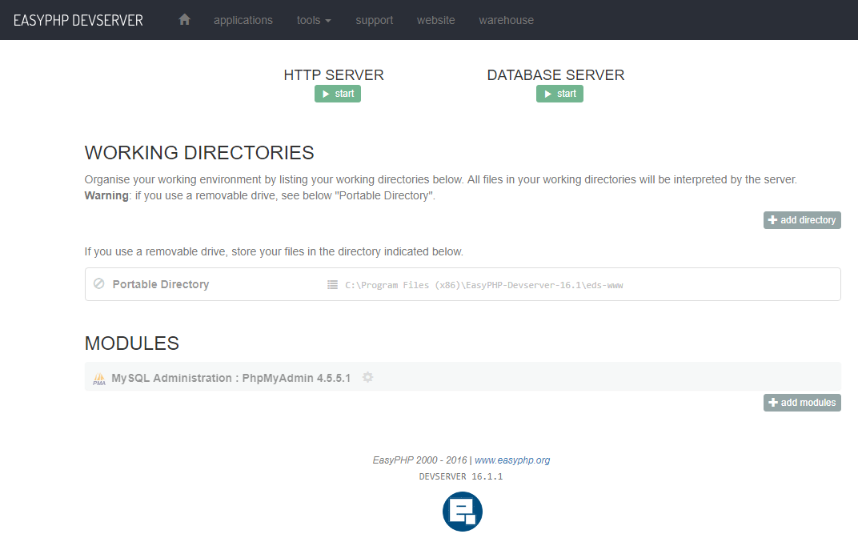

3. Click the start button under HTTP server. When prompted to choose a server, click on the Apache web server. This should bring up the Apache web server window shown below.

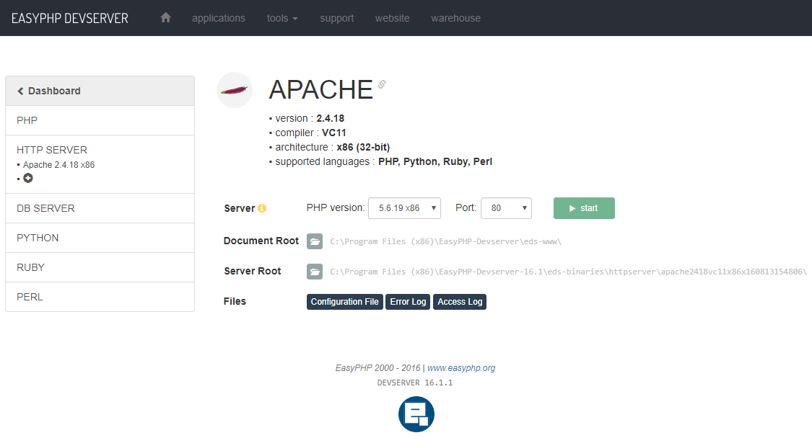

Click on the green “start” button to start the server. The screen should change, and the button should turn into a red “stop” button. If you navigate back to the home page, you’ll see that this button has also turned into a red “stop” button.

4. Start the database server by clicking the green “start” button on the home page. When prompted to choose a database server, select MySQL. This should bring up the MySQL window below

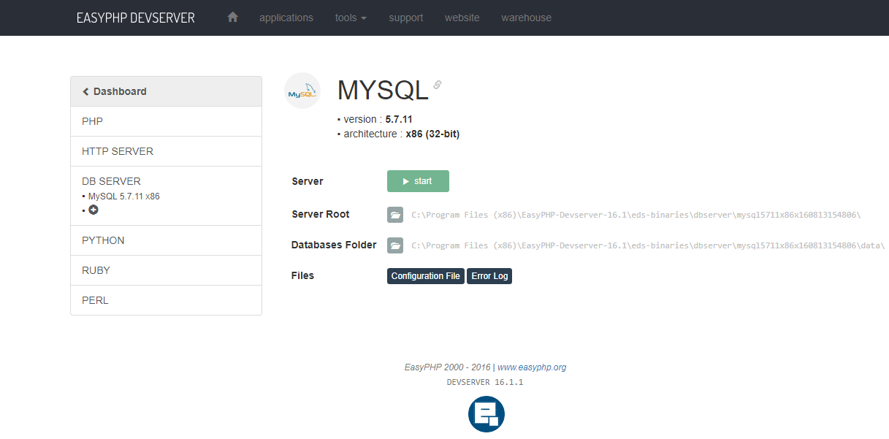

Click on the green “start” button to start the server. The screen should change, and the button should turn into a red “stop” button. If you navigate back to the home page, you’ll see that this button has also turned into a red “stop” button.

5. Navigate back to the home page, and on the line that says Portable Directory, click on the address for the eds-www directory. It should look something like C:\Program Files (x86)\EasyPHP-Devserver-16.1\eds-www

6. This directory is where you’ll place many of the files you create, organized into folders, also called your localhost. You’ll want to back up these files to your flash drive on a regular basis. For now, double click the file phpinfo.php (which is the only file available at this point). Cancel if the system offers to update anything at this point.

7. This file is opened using the Brackets editing tool, a handy way to create, read, update, and delete your files. Ignore the code on the screen for now, and select index.html from the menu bar on the left side of the screen

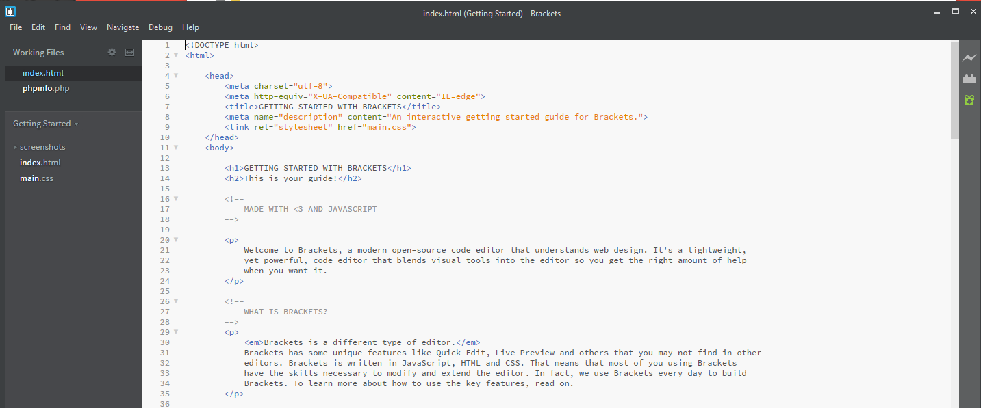

8. This file displays a quick overview/tutorial on Brackets; you may want to review this in order to familiarize yourself with the tool. Don’t worry if you don’t understand most of this, it should become clearer as we proceed through the course. You can also explore under the help and other menu options at your leisure; for now, let’s try creating and running our very first php script embedded in html.
9. From the Brackets menu select file → new to create a new file, then copy/paste or retype the HTML script below:

<!DOCTYPE html>
<html>
<head>
<title>Hello</title>
</head>
<body>
<?php
echo "<h1> Hello World </h1>" ;
?>
</body>
</html>

10. Select “save as” from the Brackets menu, then navigate to your localhost (Program Files (x86) → EasyPHP-Devserver-16.1 → eds.www and save this file as “hello.php” (leave the file type default setting “all files” and include the filetype .php on the end of your file name when you enter it into the text box). If you check back with the localhost window, you should see that this has successfully added your file with filetype php to the directory (if you just saved the file without the proper filetype, the rest of the lab won’t work).

11. Open a new browser window and enter the address http://127.0.0.1/hello.php
You should see the Hello World message displayed on a page with the tab Hello.

12. Go back to Brackets, and edit the file by adding some punctuation so that the message says Hello, World!

13. Save the file, then refresh the webpage 127.0.0.1/hello.php to see the result.

14. Take a screen shot of the final result, and upload it to iLearn or turn it in hardcopy with your name and your lab partner’s name, if applicable. If you haven’t done this before, Windows comes with a handy free application called the Snipping Tool, which lets you drag the mouse over any portion of your screen and capture the result.

